# System and Software Architecture Description (SSAD)



**Team 02**

|  |  |  |
| --- | --- | --- |
| **Member Name** | **Role** | **Email** |
| Rajat Verma | Project Manager, Lifecycle Planner, Dev | [rajatver@usc.edu](mailto:rajatver@usc.edu) |
| Preksha Gupta | Software Architect, Operational Concept Engineer | prekshag@usc.edu |
| Mangalore Rakesh Shenoy | Software Developer, Prototyper | mangalos@usc.edu |
| Ankit Gupta | Requirements Engineer, Tester | guptaank@usc.edu |
| Snehal Surendra Desai | Prototyper, Software Developer | snehalsd@usc.edu |
| Lu Wu | Quality Focal Point, Tester | wulu@usc.edu |
| Heidi Negron-Arroyo | IIV and V, Feasibility Analyst | negronar@usc.edu |

**10/15/2016**

# Version History

| Date | Author | Version | Changes made | Rationale |
| --- | --- | --- | --- | --- |
| 10/13/16 | Preksha | 1.0 | * Added System Context Diagram. * Added Use-Case Diagram. | * Initial draft for FC Package |
| 10/15/16 | Preksha & Heidi | 1.1 | * Added Artifacts & Information Diagram * Added Purpose and Status of SSAD * Added System Analysis Overview * Added Process Description and Typical Course of Action for each Use Case | * Completed for FC Package |
| 11/23/16 | Snehal | 1.2 | * Added software components description * Added process realization diagram | * Draft for As-Built Package |
| 11/30/16 | Snehal & Preksha | 1.3 | * Added Design Classes * Design Rationale * Added Architectural Styles, Patterns and Frameworks | * Completed for As-Built Package |

# Table of Contents

System and Software Architecture Description (SSAD) i

Version History ii

Table of Contents iii

Table of Tables iv

Table of Figures vi

1. Introduction 1

1.1 Purpose of the SSAD 1

1.2 Status of the SSAD 1

2. System Analysis 2

2.1 System Analysis Overview 2

2.2 System Analysis Rationale 15

3. Technology-Independent Model 16

4. Technology-Specific System Design 17

4.1 Design Overview 17

4.2 Design Rationale 24

5. Architectural Styles, Patterns and Frameworks 29

# Table of Tables

Table 1: Actors Summary 3

Table 2: Artifacts and Information Summary 4

Table 3: Process Description – Register and Pay Online 8

Table 4: Typical Course of Action – Register and Pay Online 8

Table 5: Process Description – Announcement Section 9

Table 6: Typical Course of Action – Announcement Section 9

Table 7: Process Description – Event Calendar 10

Table 8: Typical Course of Action – Event Calendar 10

Table 9: Process Description – Download Music Notes 10

Table 10: Typical Course of Action – Download Music Notes 11

Table 11: Process Description – Roster 11

Table 12: Typical Course of Action – Roster 11

Table 13: Process Description – View Video Trailer 12

Table 14: Typical Course of Action – View Video Trailer 12

Table 15: Process Description – Buy DVD 12

Table 16: Typical Course of Action – Buy DVD 12

Table 17: Process Description – Single Website 13

Table 18: Typical Course of Action – Single Website 13

Table 19: Process Description – Contact Us 13

Table 20: Typical Course of Action – Contact Us 14

Table 21: Process Description – View Yearbook 14

Table 22: Typical Course of Action – View Yearbook 14

Table 23: Process Description – Make Donation 14

Table 24: Typical Course of Action – Make Donation 14

*Table 25: Software Component Description……………………………………………………………**18*

*Table 26: Supporting Software Component Description…………………………………………….**.19*

*Table 27: Design Class Description…………………………………………………………………….21*

*Table 28: Design Class Description…………………………………………………………………….21*

*Table 29: Design Class Description…………………………………………………………………….21*

*Table 30: Architectural Styles, Patterns and Frameworks…………………………………………**25*

# Table of Figures

Figure 1: System Context Diagram 2

Figure 2: Artifacts and Information Diagram 4

Figure 3: Use Case Diagram -Online Registration and Payment System 5

Figure 4: Use Case Diagram: Announcement Section 6

Figure 5: Use Case Diagram -For User 7

Figure 6: Use Case Diagram -For Donor 7

Figure 7: Software Component Class Diagram 17

Figure 8:Supporting Software Component Class Diagram 18

Figure 9: Design Class Diagram-Registration System 20

Figure 10: Design Class Diagram-Announcement System 20

Figure 11: Design Class Diagram-Remaining System 20

Figure 12: Sequence Diagram – Online Registration and Payment 22

Figure 13:Sequence Diagram - Announcements 23

### Introduction

#### Purpose of the SSAD

The purpose of SSAD is to provide detailed description about the system architecture and its various components. It includes system context diagram which demonstrates the interaction among the various systems involved. Also, Use case diagrams demonstrate various actors and their interaction with the system.

#### Status of the SSAD

The status of this SSAD is currently at the version number 1.1, which will be submitted along with Foundations Commitment Package. This version will be reviewed with the necessary stakeholders and if there are no changes to be made, the latest version of this document will be delivered to the client.

### System Analysis

#### System Analysis Overview

VYMA is dedicated to helping young musicians feel successful through learning and sharing music. The new system is developed using Squarespace (COTS). In order to achieve this goal, the new developed system has online Registration and Payment System which is *faster* and *efficient* than mailed application. Previously, registration and payment process used to take 2 weeks. However, the new system will reduce this time to 10 minutes. The new developed system will reduce the *redundancy* by combining the three Websites (Wordpress, Shutterfly and MailChimp) and will be easy to maintain. In new system, on updating the Announcement section, an email notification will be triggered to the user. Using Squarespace‘s Search Engine Optimization feature, larger audience can be reached. Squarespace‘s Donation Block is also being utilized to provide Secure Donation feature. The new system will retain the features present in existing system like Download Music Notes.

##### System Context

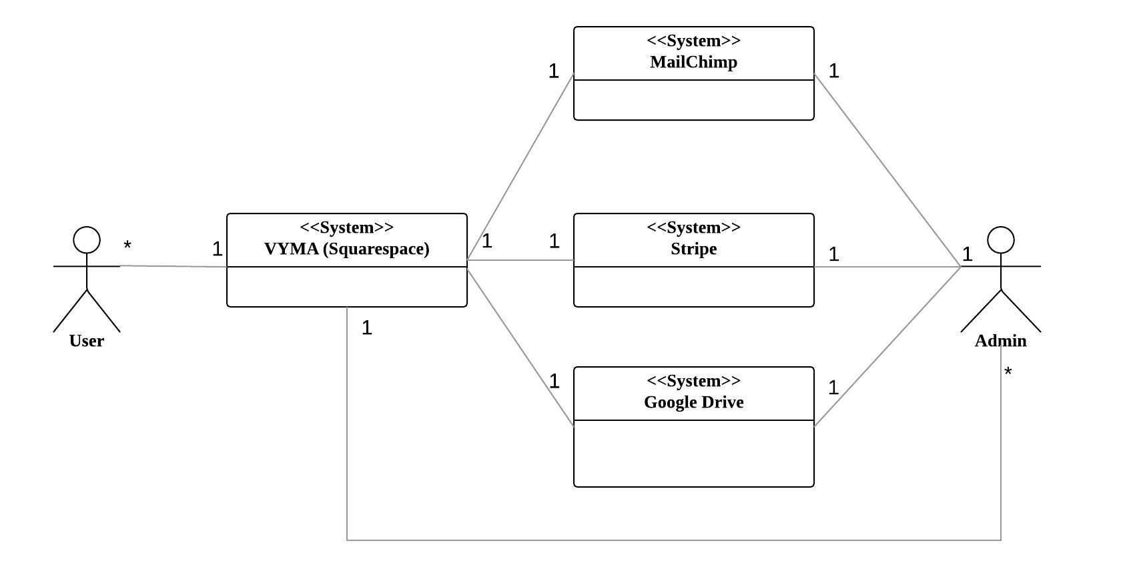

Figure 1: System Context Diagram

Table 1: Actors Summary

| **Actor** | **Description** | **Responsibilities** |
| --- | --- | --- |
| User | User of the system can either be parent or student who are older than 18 years. | * Register and Pay for courses online. * View Announcements. * Download Music Notes for Rehearsals * View Event Calendar * Give Feedbacks on Contact Us Page * View Parent’s Details on Roster |
| Admin | Admin of the system is the client who will maintain the website in future using Squarespace Control Panel. | * Manage Registration and Payment. * Update the content (add new courses) on VYMA website. * Update the Event Calendar * Update the Announcement section * Update Parent’s details on roster * Upload Music Notes * Manage Stripe for Payment * Manage MailChimp to update the mailing list to send notifications to users on update of Announcement Section. |

##### Artifacts & Information

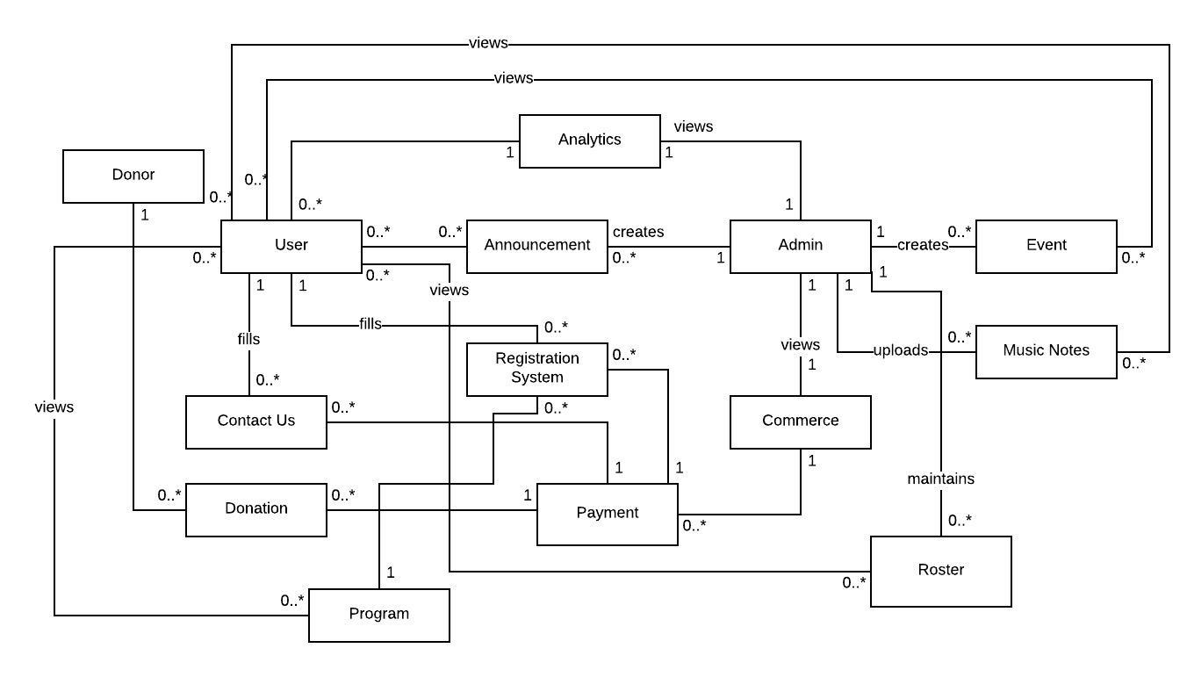

Figure 2: Artifacts and Information Diagram

Table 2: Artifacts and Information Summary

|  |  |
| --- | --- |
| **Artifact** | **Purpose** |
| ATF-1: Registration System | Contains all information for completing an application for admission into a music program, including: contact information, instrument of preference and experience |
| ATF-2: Contact Us | Contains all information necessary for making an inquiry and/or providing feedback to VYMA including contact information, and message |
| ATF-3: Donations | Contains all information necessary for making a donation, including contact information and donation amount |
| ATF-4: Event | Contains the information about an event in the Calendar, including title and date. |
| ATF-5: Announcement | Contains all information about an announcement and notifications for VYMA community and general public, including title and message |
| ATF-6: Payment | Contains all information for making a payment to VYMA including payment amount, contact and billing information. |
| ATF-7: Admin | Contains all information about admin, including email address and password |
| ATF-8: Commerce | Exports information containing all of the registration payments completed, donations, discounts and DVD orders |
| ATF-9: Analytics | Contains all the information about website traffic |
| ATF-10: User | Contains information about the user including email address, and contact information |
| ATF-11: Program | Contains information about a music program including tuition, student eligibility and audition dates |
| ATF-12: Music Notes | Contains music notes for concerts practice/rehearsals. |
| ATF-13: Donor | Contains information about Donor including contact information |
| ATF-14: Roster | Contains all information about students’ parents: contact information |

##### Behavior

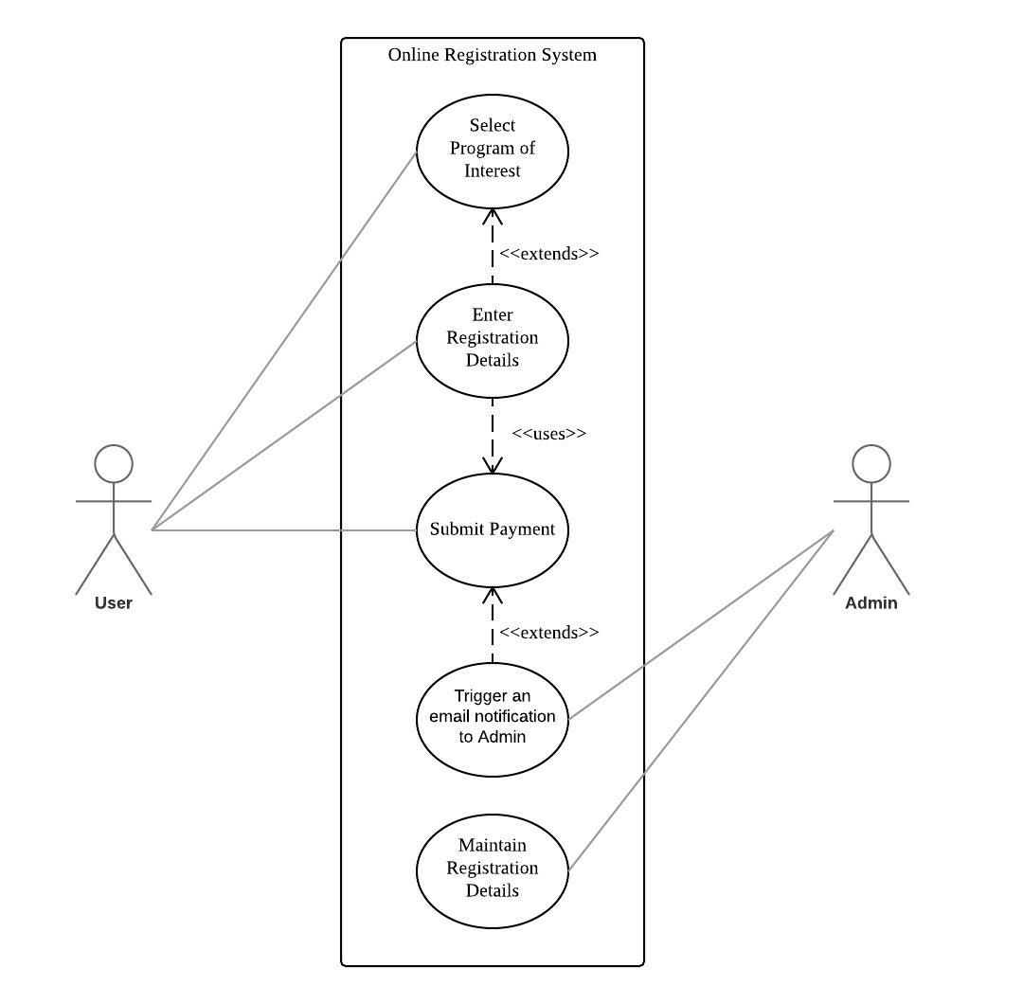

Figure 3: Use Case Diagram: Registration and Payment System

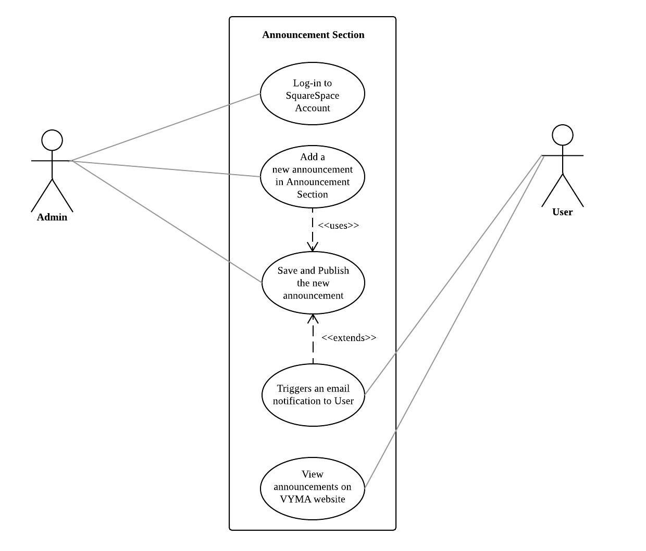

Figure 4: Use Case Diagram: Announcement Section

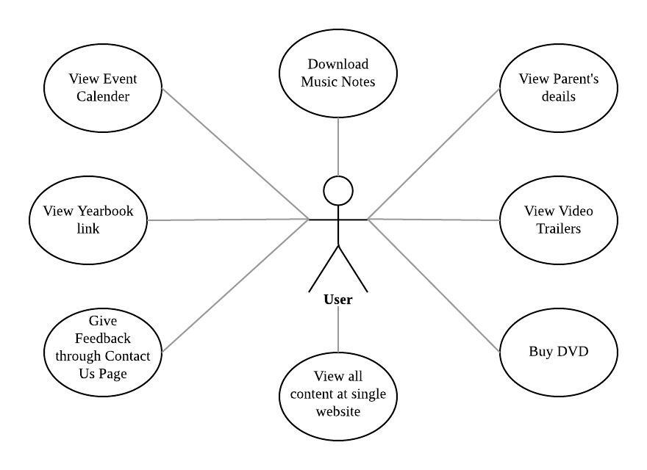

Figure 5: Use Case Diagram: For User

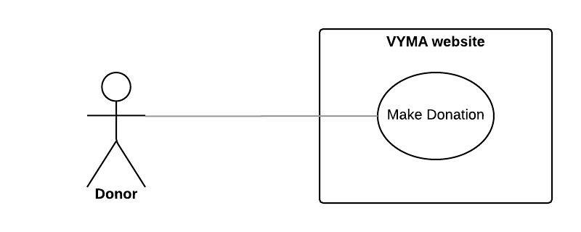

Figure 6: Use Case Diagram: For Donor

|  |  |
| --- | --- |
| **Use Case Sequence** | **Use Case** |
| UC-1 | Register and Pay Online |
| UC-2 | View Announcements |
| UC-3 | View Event Calendar |
| UC-4 | Download Music Notes |
| UC-5 | View Roster Page |
| UC-6 | View Video Trailers |
| UC-7 | Buy DVD |
| UC-8 | View all Content at single websites |
| UC-9 | Give Feedback |
| UC-10 | View Yearbook |
| UC-11 | Make Donation |

Use Case List

###### Capability: Registration and Payment System

Process: Register and Pay Online

Table 3: Process Description-Register and Pay Online

|  |  |
| --- | --- |
| **Identifier** | UC-1: Register and Pay Online |
| **Purpose** | Allows user to register and pay for courses online |
| **Requirements** | WC_4223, WC_4199 |
| **Development Risks** | COTS Integration: Squarespace and Stripe |
| **Pre-conditions** | User chooses a course to register |
| **Post-conditions** | User is registered for the course |

Table 4: Typical Course of Action- Register and Pay Online

|  |  |  |
| --- | --- | --- |
| **Seq#** | **Actor’s Action** | **System’s Response** |
| **1** | User clicks on the Program tab |  |
| **2** |  | System shows different Programs. |
| **3** | User clicks on the Program of his choice |  |
| **4** |  | System opens a page with that program’s details. |
| **5** | User chooses the Term from dropdown list |  |
| **6** | User clicks on register button |  |
| **7** |  | System open a pop up form |
| **8** | User fills his details in the form and clicks on submit |  |
| **9** |  | System adds that program to the Cart |
| **10** | User opens the cart and make payment |  |
| **11** |  | System sends a confirmation mail to user and Admin |
| **12** | Admin can go to admin control panel to manage registration and payment |  |

###### Capability: Announcement System

Process: View Announcements

Table 5: Process Description- Announcement Section

|  |  |
| --- | --- |
| **Identifier** | UC-2: View Announcement |
| **Purpose** | Admin publishes Announcements on VYMA website which can be viewed by the user. User gets email notifications for the same. |
| **Requirements** | WC_4210 |
| **Development Risks** | COTS Integration: Squarespace and MailChimp |
| **Pre-conditions** | None |
| **Post-conditions** | User receives an email Notification |

Table 6: Typical Course of Action- Announcement Section

|  |  |  |
| --- | --- | --- |
| **Seq#** | **Actor’s Action** | **System’s Response** |
| **1** | Admin logs into the Squarespace account. |  |
| **2** | Admin adds new Announcement in the Announcement Sections and publishes it. |  |
| **3** |  | System shows newly added announcement in the announcement section |
| **4** |  | System sends an email notification to the Users |
| **5** | Users view the announcement in the announcement section |  |

###### Capability: Event Calendar

Process: View Event Calendar

Table 7: Process Description

|  |  |
| --- | --- |
| **Identifier** | UC-3: View Event Calendar |
| **Purpose** | Allows user to view event and its details in Event Calendar |
| **Requirements** | WC_4212 |
| **Development Risks** | None |
| **Pre-conditions** | User knows the password to view details of Event |
| **Post-conditions** | None |

Table 8: Typical Course of Action

|  |  |  |
| --- | --- | --- |
| **Seq#** | **Actor’s Action** | **System’s Response** |
| **1** | User views event calendar on Homepage with limited details. |  |
| **2** | User clicks on event to view more details |  |
| **3** |  | System opens a page which prompts for password |
| **4** | User enters the password |  |
| **5** |  | System opens a page with event details. |

###### Capability: Music Notes

Process: Download Music Notes

Table 9: Process Description

|  |  |
| --- | --- |
| **Identifier** | UC-4: Download Music Notes |
| **Purpose** | Allows users to download Music Notes from password protected page |
| **Requirements** | WC_4226 |
| **Development Risks** | None |
| **Pre-conditions** | User knows the password to download Music notes |
| **Post-conditions** | None |

Table 10: Typical Course of Action

|  |  |  |
| --- | --- | --- |
| **Seq#** | **Actor’s Action** | **System’s Response** |
| **1** | User clicks on Members tab and select Download Music Notes from Dropdown |  |
| **2** |  | System opens a page which prompts for password |
| **3** | User enters the password |  |
| **4** |  | System opens a page with links to music notes. |
| **5** | User downloads the Music notes |  |

###### Capability: Roster

Process: View Roster Page

Table 11: Process Description

|  |  |
| --- | --- |
| **Identifier** | UC-5: View Roster page |
| **Purpose** | Allows parents to view other’s parent’s details on roster page |
| **Requirements** | WC_4203 |
| **Development Risks** | None |
| **Pre-conditions** | User knows the password to download Music notes |
| **Post-conditions** | None |

Table 12: Typical Course of Action

|  |  |  |
| --- | --- | --- |
| **Seq#** | **Actor’s Action** | **System’s Response** |
| **1** | Admin logs into Squarespace |  |
| **2** | Admin updates the Roster page and publish the details |  |
| **3** |  | System shows the roster page with parent’s details |
| **4** | User clicks on Roster page |  |
| **5** |  | System asks for Password |
| **6** | User enters the password and view Roster page |  |

###### Capability: Trailers

Process: View Video Trailers

Table 15: Process Description

|  |  |
| --- | --- |
| **Identifier** | UC-6: View Video Trailers |
| **Purpose** | Allows user to view video trailers before buying the DVD |
| **Requirements** | WC_4193 |
| **Development Risks** | None |
| **Pre-conditions** | None |
| **Post-conditions** | None |

Table 16: Typical Course of Action

|  |  |  |
| --- | --- | --- |
| **Seq#** | **Actor’s Action** | **System’s Response** |
| **1** | User clicks on Buy DVD tab |  |
| **2** |  | System opens a page with DVD details and link to YouTube where user can preview the DVD before buying it. |
| **3** | User clicks on the link and view the trailer |  |

###### Capability: ecommerce Section

Process: Buy DVD

Table 15: Process Description

|  |  |
| --- | --- |
| **Identifier** | UC-7: Buy DVD |
| **Purpose** | Allows user to buy DVD of events and Rehearsals |
| **Requirements** | WC_4193 |
| **Development Risks** | COTS Integration of Squarespace and Stripe |
| **Pre-conditions** | None |
| **Post-conditions** | None |

Table 16: Typical Course of Action

|  |  |  |
| --- | --- | --- |
| **Seq#** | **Actor’s Action** | **System’s Response** |
| **1** | User clicks on Buy DVD tab |  |
| **2** |  | System opens a page with DVD details and link to YouTube where user can preview the DVD before buying it. |
| **3** | User clicks on the link to view the trailer and click on Buy |  |
| **4** | User makes the payment |  |
| **5** |  | System sends the payment confirmation email to the User |

###### Capability: Single Website

Process: View all content at Single website

Table 17: Process Description

|  |  |
| --- | --- |
| **Identifier** | UC-8: View all content at single website |
| **Purpose** | Allows user to view all content at single website |
| **Requirements** | WC_4215 |
| **Development Risks** | None |
| **Pre-conditions** | None |
| **Post-conditions** | None |

Table 18: Typical Course of Action

|  |  |  |
| --- | --- | --- |
| **Seq#** | **Actor’s Action** | **System’s Response** |
| **1** | User can view all the content at single website rather than using three website |  |

###### Capability: Contact Us

Process: Give Feedback

Table 19: Process Description

|  |  |
| --- | --- |
| **Identifier** | UC-9: Give Feedback |
| **Purpose** | Allows user to give their feedback using Contact Us page of the website |
| **Requirements** | WC_4225 |
| **Development Risks** | None |
| **Pre-conditions** | None |
| **Post-conditions** | Admin receives an email with user’s feedback or enquiry |

Table 20: Typical Course of Action

|  |  |  |
| --- | --- | --- |
| **Seq#** | **Actor’s Action** | **System’s Response** |
| **1** | User clicks on Contact Us Page |  |
| **2** |  | System opens the Contact Us Page. |
| **3** | User fills the Contact Us Form and clicks on submit |  |
| **4** |  | System sends an email to the Admin with the feedback submitted by the user |

###### Capability: Yearbook

2.1.3.10.1 Process: View Yearbook

Table 21: Process Description

|  |  |
| --- | --- |
| **Identifier** | UC-10: View Yearbook |
| **Purpose** | Allows user to view the Yearbook on the VYMA website |
| **Requirements** | WC_4202 |
| **Development Risks** | None |
| **Pre-conditions** | None |
| **Post-conditions** | None |

Table 22: Typical Course of Action

|  |  |  |
| --- | --- | --- |
| **Seq#** | **Actor’s Action** | **System’s Response** |
| **1** | User clicks on Yearbook tab |  |
| **2** |  | System opens a page with a link to Yearbook |
| **3** | User clicks on the link and view the Yearbook |  |

###### Capability: Donation

2.1.3.11.1 Process: Make Donation

Table 23: Process Description

|  |  |
| --- | --- |
| **Identifier** | UC-11: Make Donation |
| **Purpose** | Allows user to make donation to VYMA |
| **Requirements** | WC_4227 |
| **Development Risks** | COTS Integration of Squarespace and Stripe |
| **Pre-conditions** | None |
| **Post-conditions** | None |

Table 24: Typical Course of Action

|  |  |  |
| --- | --- | --- |
| **Seq#** | **Actor’s Action** | **System’s Response** |
| **1** | User clicks on Donation Tab |  |
| **2** |  | System opens a Donation page |
| **3** | User fills the form and make payment |  |
| **4** |  | System sends payment conformation email to the user |

##### Modes of Operation

The VYMA website will have only one mode so this section is not applicable.

#### System Analysis Rationale

VYMA website is used by either Parents or Students who are older than 18 years. This website does not require any login. But there are some features which are available to only Members (students who are registered to some course). These features include downloading Music Notes, view detailed event calendar. In order to use these features, members will be provided with password to view these password protected features as soon as they register for a course. Previously, members had to go to different website to use these features. Now, members needs to be informed by the admin that all the features are being provided at a single website.

### Technology-Independent Model

Our project involved developing a website using Squarespace as specified by the client therefore we are omitting this section in the SSAD.

### Technology-Specific System Design

#### Design Overview

##### System Structure

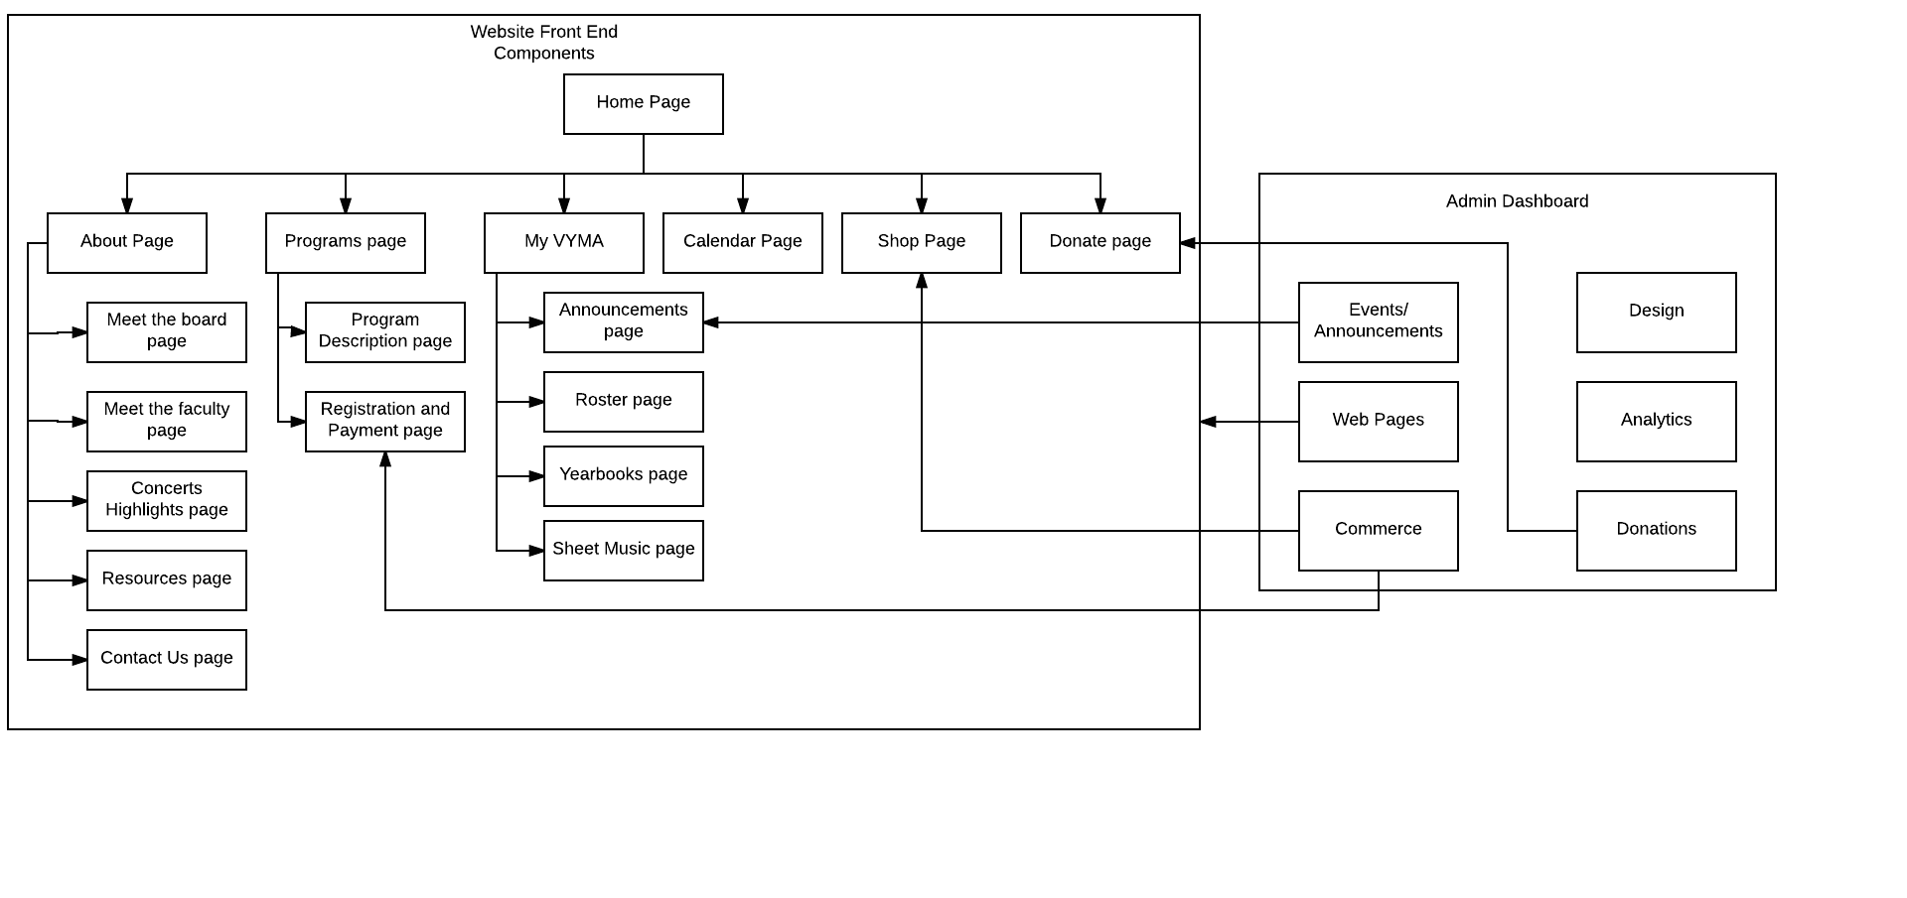**Figure 7: Software Component Class Diagram**

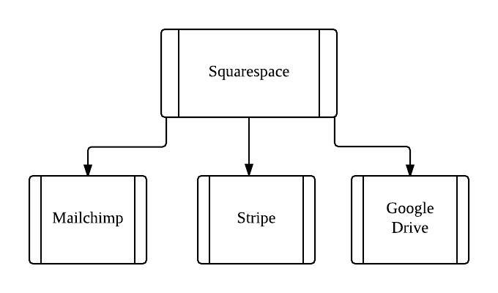

Figure 8: Supporting Software Component Class Diagram

Table25: Software Component Description

|  |  |
| --- | --- |
| **Software Component** | **Description** |
| Home Page | Page describing the mission, philosophy and VYMA’s name along with the search functionality. |
| About Page | Page describing the history and foundation of VYMA. |
| Meet the board page | Page about the board members of VYMA |
| Meet the faculty page | Page with links to pages to the faculty members. |
| Faculty page | Page with the description about the faculty members for each instrument. |
| Concert highlights page | Page with photos and videos on the highlights of previous concerts. |
| Resources page | Page with contact details of resources for luthiers, online music stores, local music stores, and local concert series. |
| Contact Us page | Page with details on how to contact VYMA along with the contact form. |
| Programs Page | Page with all the list of courses offered by VYMA. |
| Program description page | Description of the course. |
| Registration and payment page | Page to enter the student details, register and make the payment. |
| Calendar Page | Page with the calendar of events. Can be viewed by everybody. |
| Sheet Music Page | Page with the links to pdfs of the music notes. |
| Events Page | Password protected page with the details of the events. Can be viewed only by the members. |
| Announcements Page | Password protected page with all the announcements that VYMA posts. |
| Roster page | Password protected page with the details of all the current members of VYMA. |
| Yearbooks page | Page with links to the yearbook on Shutterfly. |
| Shop page | Page to view trailers and purchase DVDs of the various concerts. |
| Donate page | Page to get information on the various ways one can help VYMA and to make monetary donations. |
| Admin Dashboard | Squarespace dashboard through which the admin can edit all the pages, add or remove content, update the content, add events, announcements, view page analytics and view the payment details. |
| Web Pages | Add new pages to the website from the admin dashboard |
| Commerce | Manage the transactions made from the website |
| Donations | Manage the donations made from the admin dashboard |
| Analytics | View the traffic overview and page hits from the admin dashboard |
| Design | Deals with the templates and design of the web pages from the admin dashboard |

Table 26: Supporting Software Component Description

|  |  |
| --- | --- |
| **Support Software Component** | **Description** |
| Mail chimp | Mail chimp is used to manage the subscribers of the newsletter and to trigger email notifications when any announcements are posted. |
| Stripe | Stripe is used for managing payments(payments for courses and donations). |
| Google Drive | Google drive is used to manage the registration and roster details. |

##### Design Classes

###### Registration System

**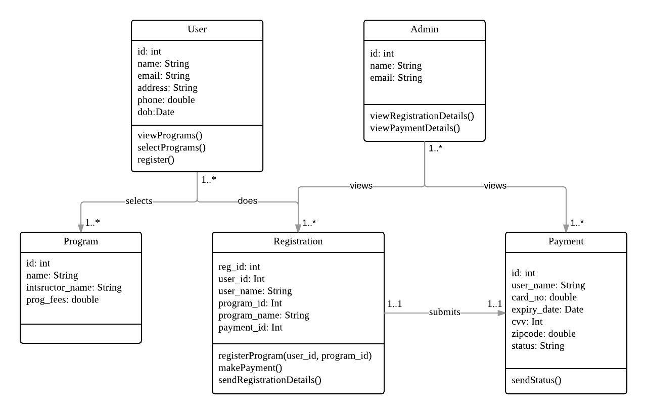****Figure 9: Design Class Diagram****-Registration and Payment System**

Table27: Design Class Description

|  |  |  |
| --- | --- | --- |
| **Class** | **Type** | **Description** |
| User | Entity | Anyone who uses the website(members and non-members) |
| Admin | Entity | The client and maintainers at VYMA who will make the changes via Squarespace’s admin dashboard |
| Program | Entity | All the courses and programs offered by VYMA that the students can opt for. |
| Registration | Component | Register for various courses and programs offered by VYMA. |
| Payment | Component | Payment details and transactions for the various courses, DVD’s and/or donations. |

**Announcement Section:**

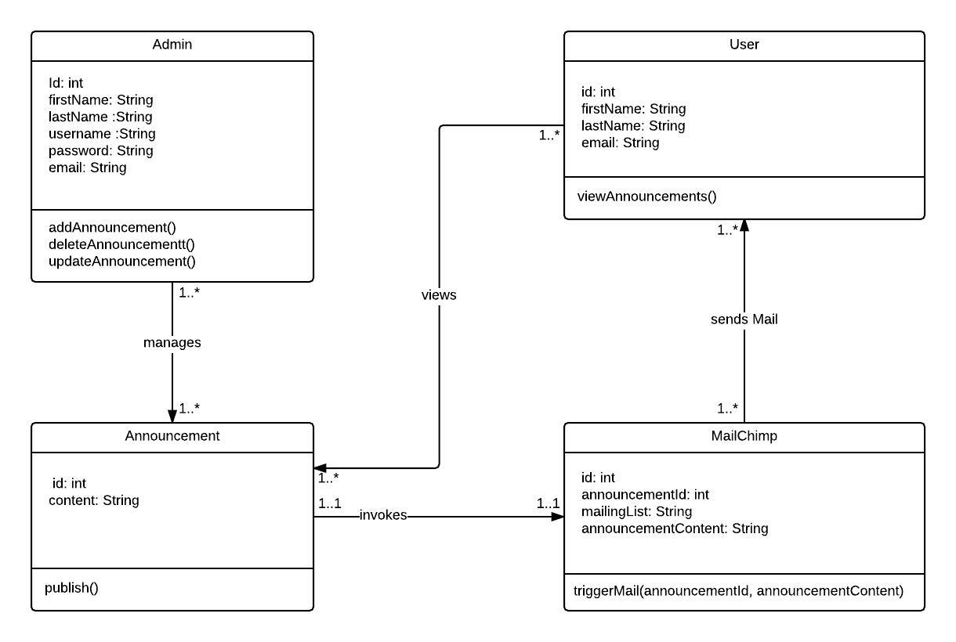

**Figure 10: Design Class Diagram-Announcement System**

Table28: Design Class Description**-Announcement System**

|  |  |  |
| --- | --- | --- |
| **Class** | **Type** | **Description** |
| User | Entity | Anyone who uses the website(members and non-members) |
| Admin | Entity | The client and maintainers at VYMA who will make the changes via Squarespace’s admin dashboard |
| Announcement | Component | Announcement section contains various announcements about upcoming VYMA events. |
| MailChimp | Component | MailChimp is used to send email to Users whenever Admin updates the Announcement Section. |

**Remaining Sections**

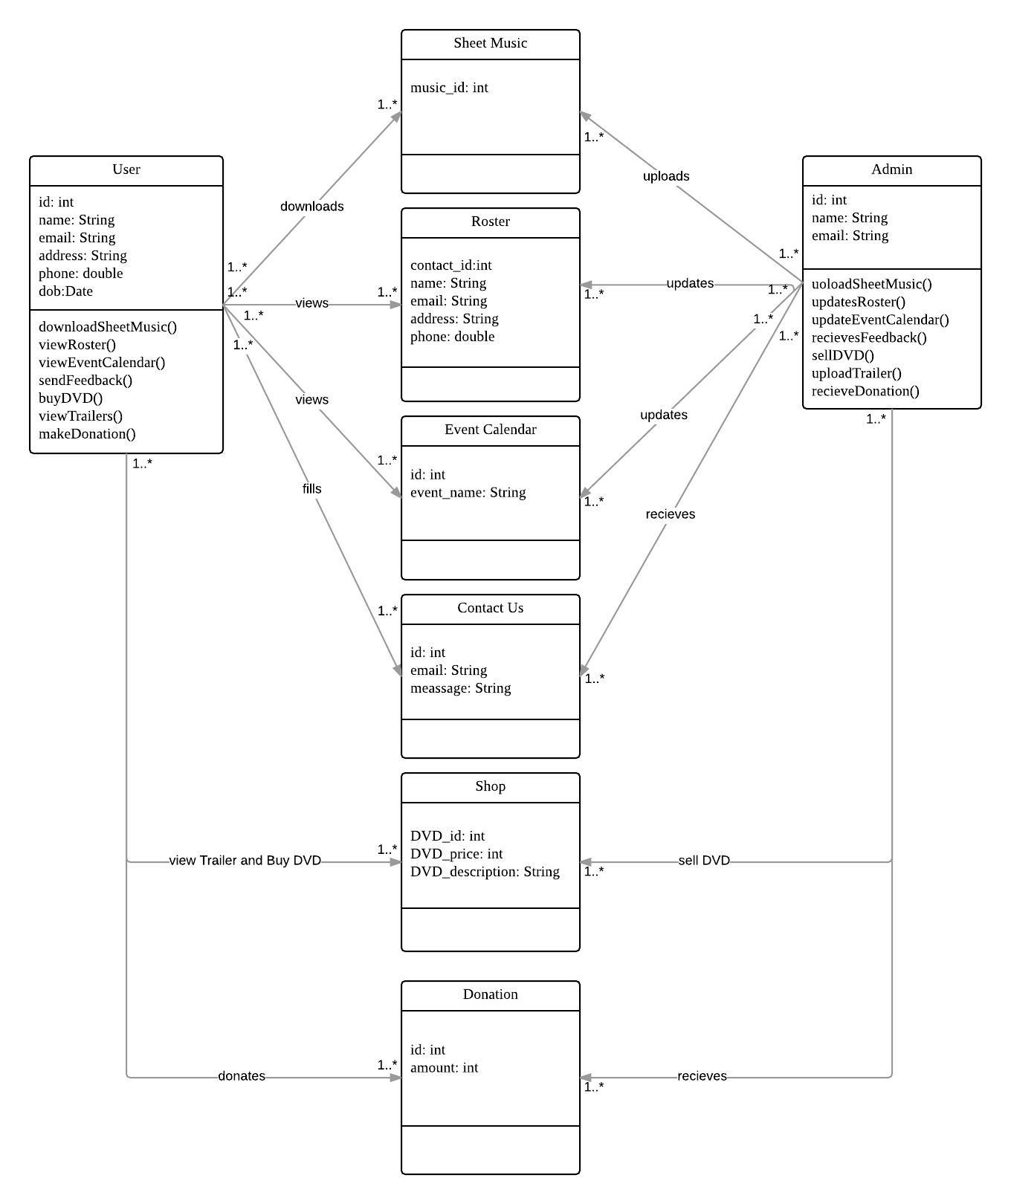

**Figure 11: Design Class Diagram-Remaining System**

Table29: Design Class Description **-Remaining System**

|  |  |  |
| --- | --- | --- |
| User | Entity | Anyone who uses the website(members and non-members) |
| Admin | Entity | The client and maintainers at VYMA who will make the changes via Squarespace’s admin dashboard |
| Sheet Music | Component | User downloads Sheet Music before every class to practice the music. |
| Roster | Component | Roster contains parent’s details of all the students. |
| Event Calendar | Component | Event Calendar contains all the upcoming VYMA event and their details. |
| Contact Us | Component | User can contact VYMA through Contact Us forms to give their feedback |
| Shop | Component | User can view Trailers and Buy DVD of concerts. |
| Donation | Component | User can make donation to support VYMA |

##### Process Realization

In this section, we have created sequence diagrams for the modules which were difficult to understand. **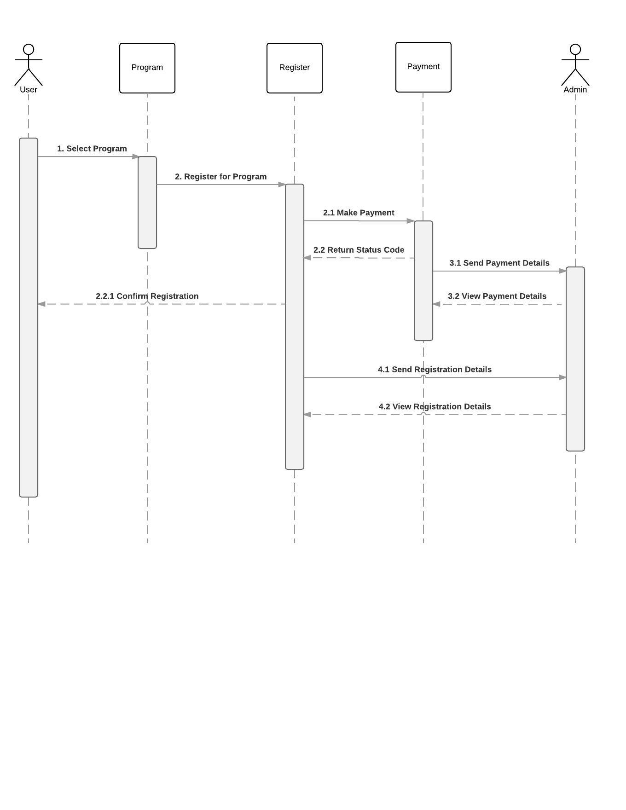****Figure 12: Sequence Diagram: Online registration and Payment**

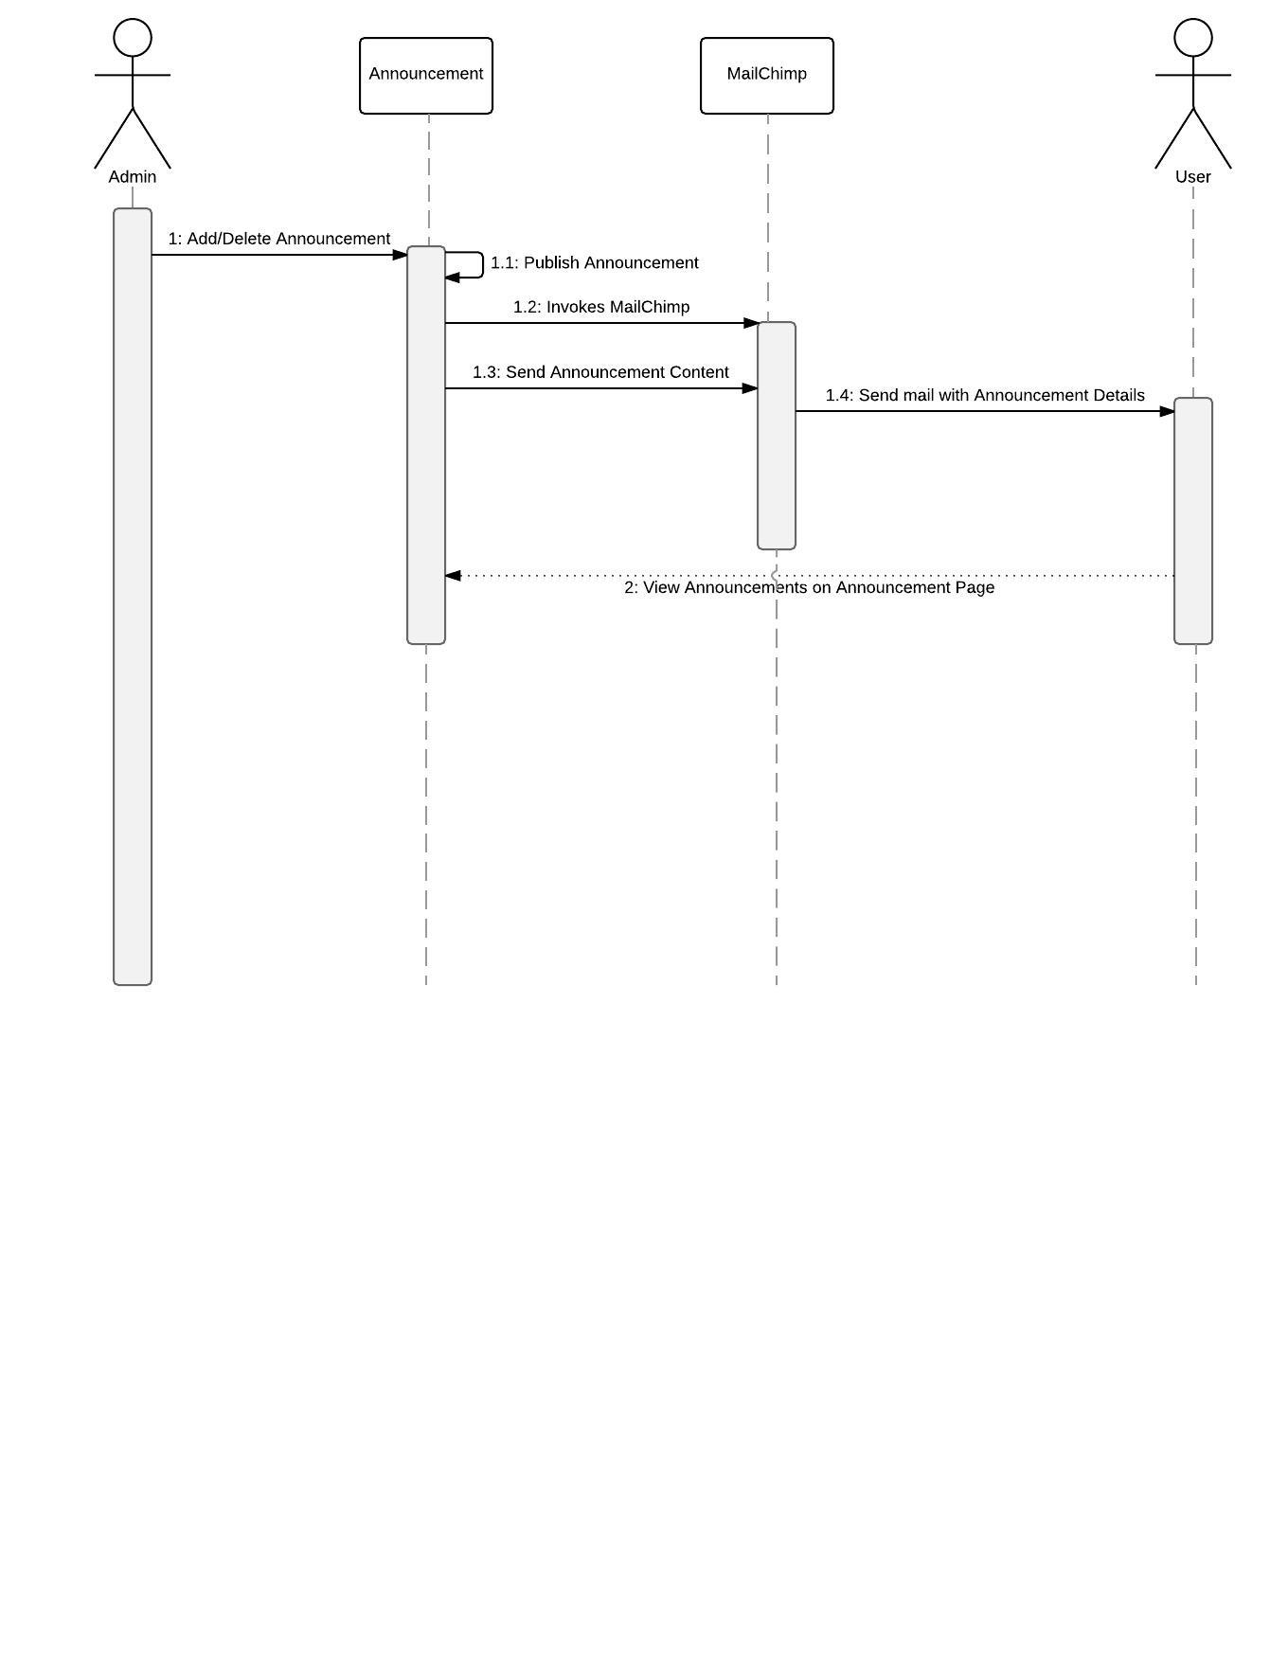

**Figure 13: Sequence Diagram: Announcements**

#### Design Rationale

Our client had shown interest in using Squarespace for the development of the website due to its user friendly features and 24*7 customer support service. Our team did a complete analysis and survey on the different options and decided that Squarespace indeed would be the best choice for this project.

WordPress and Wix were the other two options.

The following are the reasons behind choosing Squarespace:

* Templates are of better quality, responsive and mobile-compatible
* Opportunity for making changes to templates and website capabilities are provided via a developer platform tool
* No coding experience needed for adding functionalities from Squarespace official integrations. This was an important feature for maintenance purposes.
* All pricing plans offer hosting, maintenance and security
* 24/7 chat/email customer support
* The pricing plan was in accordance with the budget given to us by the client.

Mail Chimp is used because the client had been using it for managing the newsletters on their old system. Also, squarespace supports Mail Chimp as well. The new system uses Mail Chimp for maintaining the mailing lists for the newsletters and for sending out emails to the subscribed members whenever a new announcement is posted on the website.

Stripe was chosen for all the payment transactions due to its ease of use and integration with Squarespace.

### Architectural Styles, Patterns and Frameworks

|  |  |  |
| --- | --- | --- |
| **Name** | **Description** | **Benefits, Costs, and Limitations** |
| Squarespace | Content Management System that provides website creation and customization tools (e.g. developer platform), hosting, and customer support. | For $18/month, Squarespace takes charge of all aspects of website creation while allowing some degree of customization: user-friendly templates website server maintenance, hosting and complete third party service integrations for supporting payments, marketing etc.  Website customization is limited by what Squarespace provides support for and the features they offer. The set of features available will depend on the plan selected (which has cost implications).   * Squarespace does not make public implementation-specific details. |
| Service- Oriented Architecture | Squarespace supports integration with other services, which are used for creating the VYMA website and support different features such as email newsletters and tuition payments. | Limited availability of third-party services that are already fully compatible with Squarespace.  Squarespace provides a developer platform for customizing code and potentially adding new functionality using other external services. It does not guarantee full compatibility.  The developer platform is available with the purchase of Squarespace plan. |
| Three- tier architecture | Squarespace has different modules for managing the website creation: user interface, data storage, and business logic. | This architecture allows better data management, security and robustness.  Each module could possibly be changed/updated without affecting any other module.  Client cannot access database directly.  Adds complexity to website development and maintenance. |

Table 30: Architectural Styles, Patterns, and Frameworks